

IS 200 - SYSTEMS ANALYSIS AND DESIGN

CONVERSION STRATEGY & GANTT CHART

COURSEWORK


YEAR 2 SEMESTER 1

PREPARED ON 6th/12/2024

 | GROUP MEMBERS
S/NO | REGISTRATION NUMBER | STUDENT NAME
1 | SEP23/BCS/3472U/F | NABATANZI GORRET
2 | SEP23/BCS/3698U | KOBUMANZI ESETHER
BY
a) Recommend a conversion strategy that will be used to roll out the new system in the organization.

A Conversion Strategy refers to the approach used to transition from an existing system to a new system. The conversion strategy recommended for WITI’s Student Management System is a Phased (Gradual) Conversion, as it allows the institution to transition smoothly and gradually to the new Student Management System (SMS), by implementing and testing modules of the system for use while continuing to use the existing file-based system (Google Sheets/Excel).

The Phased Conversion involves a gradual introduction of the new system, while at the same time replacing elements of the current system until the current system is completely replaced by the new system. It allows users to adapt incrementally while minimizing risks associated with a direct conversion. This conversion method is the least risky with respect to implementing the WITI’s student management system.

Reasons for Choosing a Phased Conversion Strategy
- Minimal Risks: By implementing the system module by module, any potential issues can be identified and resolved before the full system is deployed.
- User Training and Adaptation: Staff and students can be trained on specific components of the system during each phase, reducing the learning curve and ensuring higher user adoption.
- Minimal Disruption: Core operations of the institution can continue running without interruption, as the existing system will remain operational for areas not yet transitioned.
- Data Integration: During the transition, data from Google Sheets/Excel can be imported incrementally into the new system, ensuring data consistency.
- Scalability and Feedback: Each phase allows the institution to gather feedback, improve functionalities, and make adjustments on the remaining modules before full deployment

Phased Roll-out Plan
A roll-out refers to the process of deploying and implementing a new system or software within an organization. Our plan involves a phased and structured deployment of modules ensuring minimal disruption, early identification of issues, and smooth integration of the new system into the institution's operations.

The following are the Roll-out Phases that will be used for the conversion strategy identified;
Phase 1: System Administration
This will be the pilot phase since it establishes system administration and access control, a critical foundation for subsequent modules. It will enable user management and role-based access for users. It will consist of the following roll-out tasks;
- Deployment of the the Admin Module (users, roles and settings management).
- Creating roles, users like admins and facilitators and assigning them roles.
- Testing user account creation, password policies, and role-based restrictions.
- Providing training on system administration.

Phase 2: Programs Management
This phase will then come next since it defines the academic structure (programs, semesters, and courses), which is essential for enrolling students and managing academic data. It will consist of the following roll-out tasks;
- Deployment of the Programs Module (programs, semesters, courses).
- Migrating existing program and course data from the existing Google Sheets/Excel.
- Setting up semesters and courses.
- Testing program creation, updates, edits and course linking with semesters.

Phase 3: Facilitator Management
This phase will be followed up so as to assign facilitators to courses they teach ensuring that course management is ready before student enrollment. It it will be made of the following roll-out tasks;
- Deployment of the facilitator module
- Importing facilitator details into the system.
- Assigning facilitators to specific courses.
- Testing workflows for updating and managing facilitator course assignments.

Phase 4: Student Management
This roll-out phase will then be followed to enable management of applications, student data and enrollments, integrating with existing facilitator and course data. It will involve the following roll-out tasks;
- Deployment of the student module (applications, students registration, enrollments).
- Transferring existing student data into the new system.
- Testing the data added.

Phase 5: Attendance Management
This phase will involve rolling out the attendance module using the following tasks;
- Rolling out the QR Code-Based Attendance features.
- Training faculty and students to use the QR scanning functionality.
- Testing attendance records for accuracy and consistency.

Phase 6: Grading and Reporting
This phase will involve rolling out of the assessment features for grading and reporting analysis with the following tasks;
- Deploying the Grading Management and Analytics Modules.
- Training faculty to input and manage grades using the system.
- Testing reporting features by faculty and administrative staff.

Phase 7: Full System Deployment
This will be the last phase to ensure that all the system features are fully integrated and work seamlessly together. It will include the following roll-out tasks;
- Integration of all modules and extending the system to all users.
- Conducting system-wide testing and finalize documentation.
- Providing continuous support and troubleshooting as users fully transition to the new system.

Benefits of the Phased Approach
- Incremental implementation allows for iterative improvements.
- Users become familiar with the system gradually, reducing resistance to change.
- The institution can manage resources effectively without overwhelming staff or budgets.

In conclusion, we recommend a Phased (Gradual) Conversion strategy for rolling out the Student Management System for Women In Technology Uganda since it minimizes risks, allows for iterative improvements and ensures smooth transitioning, by implementing and testing modules of the system in phases for use while continuing to use the existing file-based system until the whole system is fully ready, thus ensuring that WITI successfully adopts to the new system effectively.

b) Develop a Gantt chart to show us how you plan to carry out the project.
A Gantt chart is a visual representation of a project schedule, showing the start and finish date of several elements of a project. It is used to plan and track the tasks and phases of a project as seen below.
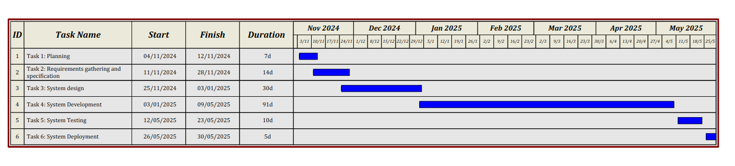
Figure 1: A Gantt Chart showing the project timeline

